**Video Links**

I’m not sure how many of these I’ll end up making, but for now here are useful video links.

**Project 10**

* Recursive Descent Parsing and the JACK Grammar  
  [ECEG 431: Recursive Descent Parsing and the JACK Grammar](https://youtu.be/zBKbPDA1O5M)
* compilationEngine Overview  
  [ECEG 431: compilationEngine Overview](https://youtu.be/LUM_F-VRTYA)
* Project 10 Code Walkthrough of Advance  
  <https://youtu.be/Xu0Wf3St92w>

**Project 9**

* JACK language Hello World

[P09 JACK Hello World](https://youtu.be/nf3rAHuAFJ4)

* Introduction to Object Oriented programming (in JACK)
* [P09 Object Oriented Intro](https://youtu.be/UXAWz60NKaw)
* Linked Lists in JACK (and how objects are stored in memory)
* [P09 Linked List](https://youtu.be/FuJtFQgYbYw)
* Short walk through of the JACK language syntax
* [P09 Jack Syntax](https://youtu.be/viWU47wkyTI)

**Project 8**

* Walk through of a Function Call and Return

<https://www.youtube.com/watch?v=DJXoMo9jHsI>

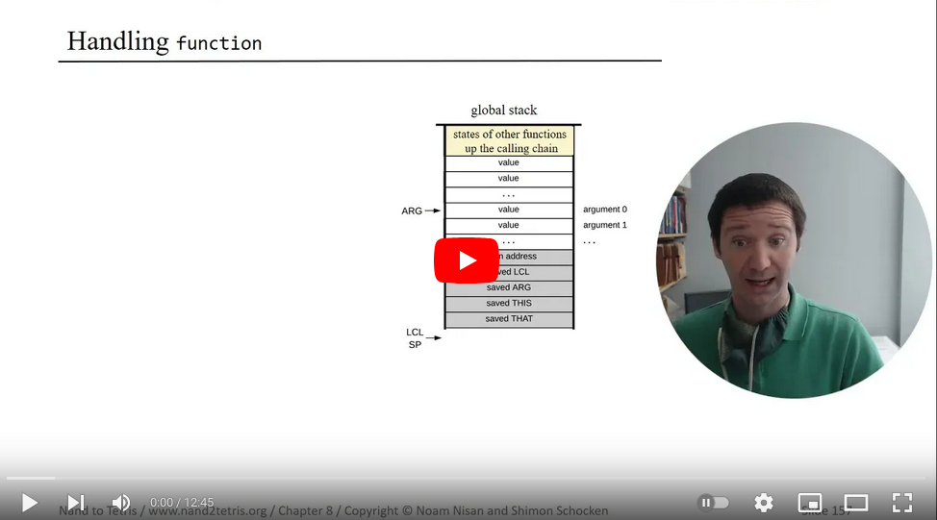

(that thumbnail youtube chose is just sort of awesome. I couldn’t resist posting it. All hail our AI overlords for recognizing beauty.)

* Factorial Recursion

<https://www.youtube.com/watch?v=e2oc7BCOEMM>

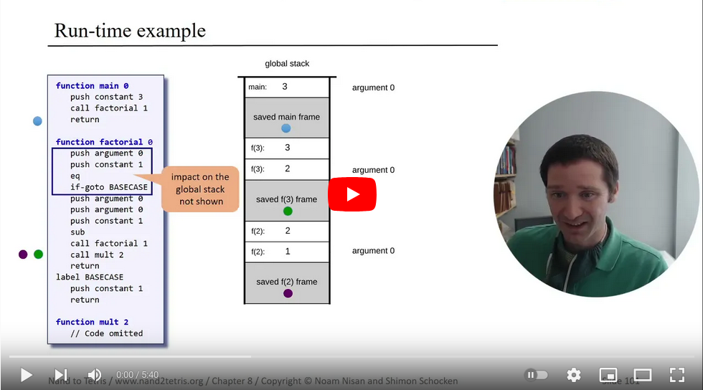

* Booting -- Stack Initialization and calling sys.init()

<https://www.youtube.com/watch?v=5VvSzOGJkeA>

